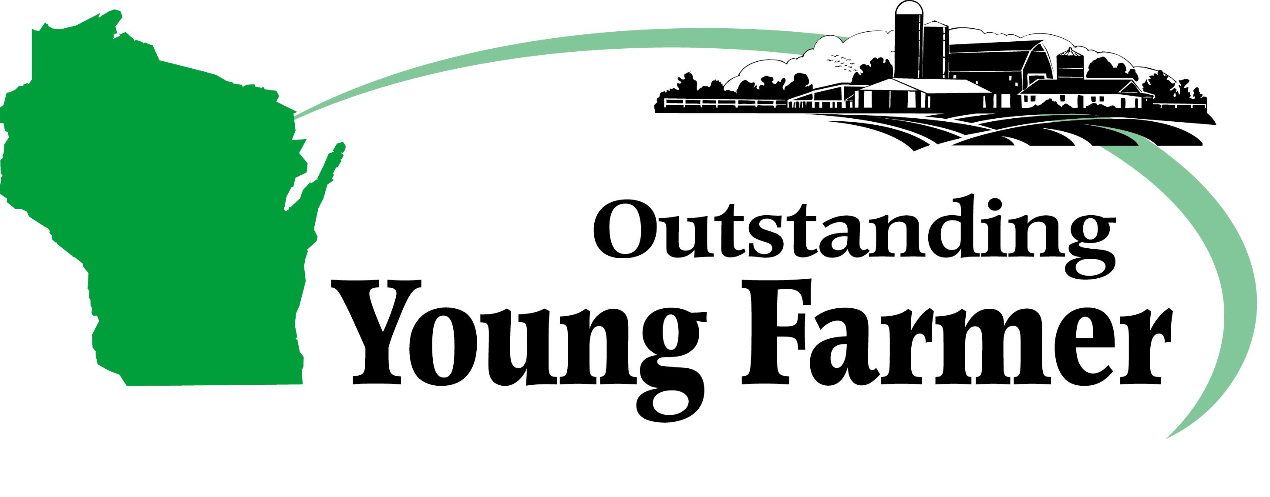

1222 Hawthorne Street, Eau Claire, WI 54703

Dear Wisconsin Business Owner/Manager/OYF Member,
Wisconsin is proud to announce the 70th State Outstanding Young Farmer (OYF) Awards Congress will be held at the Hotel Mead in Wisconsin Rapids the weekend of January 26-28, 2024. We will bring together a group of Wisconsin’s best young farmers aged 21-40, to thank them for the selfless work that they do while making an impact on their community and state. We recognize our finalists throughout the weekend, and we also recognize our state winner who will move on as Wisconsin’s 2025 National OYF Candidate.
To make the event successful, we are looking for businesses that would like to showcase their products or their business to Wisconsin and to the attendees during the Awards Congress. Here is a list of opportunities for your business:
- **New** Premium Sponsor Level - 3-year commitment with headlining opportunities (see next page for details)
- Monetary donation to sponsor finalists (approx. $800-$1,000 per couple)
- Monetary donation to sponsor: Tour bus $500; Meals: Friday Lunch $500; Friday Banquet $1000; Saturday Breakfast $500; Saturday Lunch $500; Saturday Banquet $2000; Hospitality Room: $1500 weekend; Award $1500-$2000 cash awards to winners
- Silent Auction Items
- Items made in Wisconsin for a gift bag to be distributed to all finalists and special guests for the weekend

Please review the attached form that displays our many sponsorship levels and shows what your business would receive in return for your donation. Feel free to call or email with any questions to 715.833.9649 or wi-oyf@charter.net.

Thank you for your time and support of our state’s young farmers through your generous contribution to this awards congress.
Please send the bottom portion with your donation to: Wisconsin OYF
Cindy & Harold Matton
1222 Hawthorne Street
Eau Claire, WI 54703
Please return bottom portion of this form with your sponsorship/donation
SPONSORSHIP / DONATION
Enter an X on your level of Sponsorship

Amount ___________________ Premium ____ Diamond ____ Platinum ____ Gold ____ Silver ____ Bronze ____ Supporter ____

Candidate/Name __________________________________ Tours ____________ Meal(s) ___________ Hospitality ___________

Other_____________________________________________________________________________________________________

Silent Auction Item(s) ______________________________________________________ Value of items ____________________

Your Name: ______________________________________________________________________________________________

Company: ________________________________________________________________________________________________

Address: _________________________________________________________________________________________________

City, State, Zip: ___________________________________________________________________________________________

Phone: ________________________________ Email: ____________________________________________________________

